Professional Nurse Editors & Statisticians LLC (ProNES)
STAT PAK PLAN

This form identifies the analyses needed for the project or research study. Please indicate all descriptive and inferential statistics needed for the import into the manuscript. Additional analyses or statistics that are not included on this stat pak may be subject to additional charges if extensive or require the creation of a new SPSS database.

Name of Doctoral Investigator:

Write out PICOT:

Date of IRB approval:
Dates of Data Collection:
PROPOSAL:
Type of Analysis:
Between Group
Within Group
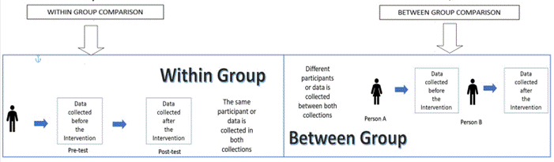
Independent Variable = Quality Improvement =_____________________________________
Dependent Variable (s) = Outcome = _____________________________________________

Variables
 | Name of Variable | Level of Measurement
Demographics
Variable collected at Preimplementation or Baseline
Variable collected at Postimplementation

Recommended Statistical Analysis:
Descriptive Stats Desired
Means, standard deviations and ranges of demographics: (Indicate below:)

Frequencies and percentages of descriptive variables (Indicate below:)

Level of Measurement | Independent Samples | Dependent or Paired Samples
Ratio or Interval | Independent samples t-test | Dependent or Paired samples T-test
Ordinal | Mann Whitney U | Wilcoxon Signed Rank
Nominal | Pearson chi-square | McNemar's Exact Test

Inferential Stats Desired
T -Test Paired or Independent
Chi-square Test Paired or Independent
Mann Whitney U Test Independent
Wilcoxon Test Paired
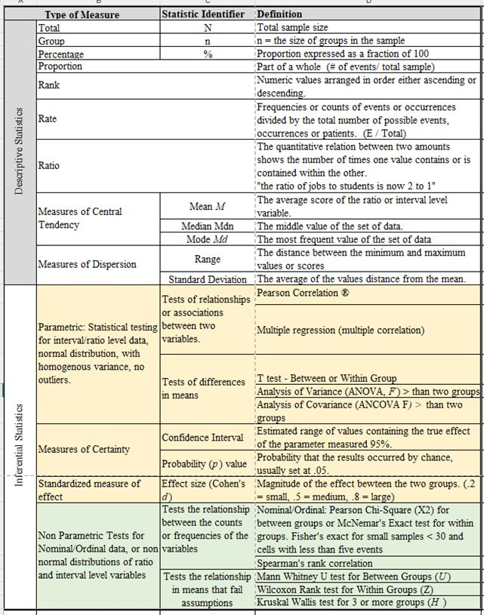Significance Level Desired: A significance level of .05 or less was used to establish statistical significance here. Please update if different.

Multiple Independent or Dependent Variables
Analysis of Variance
Multiple or Logistic Regression
Psychometric Analysis

Sample Size Estimation Based on Feasibility and Statistical Criterion:
Power .8
Effect .5
Significance. 05

For an independent sample t test or Mann Whitney U using the above criteria, the minimum sample size recommended for the project is 102 with 51 in each group.
For a paired sample t-test using the above criteria, the minimum sample size recommended for the project is 27.
For a Pearson’s chi-square test using the above criteria, the minimum sample size recommended for the project is 32
For a McNemar’s exact test using the above criteria, the minimum sample size recommended for the project is 30.
For a Wilcoxon Signed Rank test using the above criteria, the minimum sample size recommended for the project is 28.

Minimum Sample Size_____________recommended for a powerful, effective and statistically significant result.
References for effect size, power, and significance.
The ideal power of a study is considered to be 0.8 (which can also be specified as 80%). Sufficient sample size should be maintained to obtain a Type I error as low as 0.05 or 0.01 and a power as high as 0.8 or 0.9.
Source: Serdar, C. C., Cihan, M., Yücel, D., & Serdar, M. A. (2021). Sample size, power and effect size revisited: simplified and practical approaches in pre-clinical, clinical and laboratory studies. Biochemia medica, 31(1), 010502. https://doi.org/10.11613/BM.2021.010502
The effect size is also reported but may not be included in the QI project. While a P value can inform the reader whether an effect exists, the P value will not reveal the size of the effect. In reporting and interpreting studies, both the substantive significance (effect size) and statistical significance (P value) are essential results to be reported.
Source: Sullivan, G. M., & Feinn, R. (2012). Using Effect Size-or Why the P Value Is Not Enough. Journal of graduate medical education, 4(3), 279–282. https://doi.org/10.4300/JGME-D-12-00156.1

Post hoc Analysis Needed: -
Assumption Testing
Analysis of Variance
Other

PLAN FOR DATA ANALYSIS
- Clearly states the clinical question for the DNP project or the research objectives and hypothesis for the Ph.D. thesis.
- Identifies the dataset used, e.g., Microsoft Excel or other comma-delimited text, to collect and prepare the data for analysis.
- Share any Inclusion and exclusion criteria of data that will or will not be included and why.
- State the independent and dependent variables as defined in the manuscript. Identify their level of measurement, including any coding used for nominal or ordinal levels. Coding is used to provide a numerical value for a variable which is a category or count. For example, males would be coded to 1 and females coded to 2 because the statistical program cannot analyze the text as male or female. Instead, it analyzes the 1s and 2s and nominal level data. See the Mock Database associated with this document.
- State the desired outcomes of the clinical questions for DNP projects or Ph.D. research hypotheses using the planned statistical tests.
- Indicates the software for statistical analysis, e.g., SPSS version 28.
- Identify missing data and outliers and determine a plan for use or removal. Plan to discuss the background for any issues.
- Describe the sample using demographic variables, e.g., age, gender, and diagnosis. These are reported in a table using means, standard deviations or counts and percentages (see Tables)
- Identify the statistical tests based on the variables' levels of measurement.
Parametric Tests using within group or between group t-tests. If it fails assumption testing, it can report Wilcoxon Signed Rank or Mann Whitney U.
Non-parametric Tests for between groups involve the Pearson Chi-square test and Fisher's Exact test. Within group comparisons, use the McNemars Chi-square test.
Multivariate analyses may involve analysis of variance, Kruskal Wallis, multiple and logistic regression.
- Creating shell tables and planned figures of results using APA style.
- Write a narrative that addresses all entries in the tables and figures in the text. Both should stand alone.

Data Analysis Process
1. Received data in Microsoft Excel on N = xx patients . Examined for missing data and errors. Eight records were missing the length of stay data or were transferred/expired. Therefore these records were not included in the inferential analysis. A data sample from 60 patients were included in the project.
2. The descriptive variables of age, gender, marital status, and ethnicity were collected. The biometric measures of pain, temperature,, mean arterial pressure, pulse, lactate level and mental status were collected. The times of antibiotic administration time, crystalloid administration time, admission time to bundle completion and length of stay were collected. Variables were reported either as ratio level using means, standard deviation and range; or as nominal level categories transformed using numerical codes and reported using counts and percentages. The data for N = xx patients were entered into an SPSS version 28 database for descriptive analysis. These demographic and biometric variables were described in the narrative and displayed in a table (see Tables). The categorical data was displayed in a table and graphed using bar charts (see Figures). These data are presented descriptively so frequencies between the groups and overall can be discussed.
3. Parametric statistics like the t-test require assessment of four main assumptions: (Please let us know if these need to be assessed in your project)
a. Independence of the observations. Each score was obtained from one patient. No variables were shared.
b. No significant outliers in the two groups. Plots of the variables and Z scores were calculated to check for outliers. Any z score > 3.0 was considered an outlier due to being 3 times the standard deviation.
c. Normality. The data for each group’s variables should be approximately normally distributed. Shapiro Wilk was performed to check normality. If the p < .05, the values are not normally distributed in the dependent variables. This significance is a violation of normality.
d. Homogeneity of variances. the variance of each outcome variable should be equal in each group. Levene’s test was performed to check for the assumption of homogeneity of variance. If Levene’s test significance value is significant (p < 05), the assumption is violated, and the variance is heterogeneous.
e. Violations to assumptions: If the assumption of normality or homogeneity is violated, or outliers are present, then the t-test may not be the most powerful test available, and this could mean the difference between detecting a true difference or not. A nonparametric test or employing a transformation may result in a more powerful test.
4. Nonparametric tests are completely based on the ranks of the categorical or ordinal data, which are assigned to the ordered data. Nonparametric analyses are used when the outcome is a nominal, ordinal variable or a rank, when there are definite outliers or when the outcome has unclear limits of detection. Non-parametric statistics require that the observations are unrelated to one another. There is underlying continuity in the variable under investigation. They are less sensitive than their parametric counterparts when the assumptions of the parametric methods are met.

Example of Narrative and Tables
Data from xx patients were collected to assess the impact of the QI on the OUTCOME. One or Two groups were identified using electronic medical records. A comparative/preimplementation group of xx patients was collected before implementation. An postimplementation group of xx patients was collected after implementing the QI. As noted in Table 1, the mean age (years) of the comparative/preimplementation group was xx years (SD = xx), with a range of xx -xx years. The mean age of the postimplementation group was xx years (SD = xx), with a range of xx -xx years.
OR
Data from xx patients were collected at baseline to assess the impact of the QI on the OUTCOME. As noted in Table 1, the mean age (years) of the patients at baseline was xx years (SD = xx), with a range of xx -xx years.
Table 1
Demographic Characteristics of Patient Sample (N = )
Baseline characteristic | Sample
 | M | SD |  | Range
Variable
Variable
Variable
Note. N = This table used mostly with a paired sample

Race, ethnicity, and language were described using frequencies and percentages (see Table 2), The comparative/preimplementation group’s racial makeup was 32% White (n =78), 32% Black (n = 72), 1% Hispanic (n =3), 7% Asian (n =17), and 29% other (n =72).

Table 1
Demographic Characteristics of Patient Sample (N = )
Baseline characteristic | Comparative/preimplementation |  |  | Postimplementation
 | M | SD | Range | M | SD |  | Range
Variable
Variable
Variable
Note. N = This table used mostly with a paired sample

Table 1
Demographic Characteristics of Patient Sample (N = )
Baseline characteristic | Preimplementation  (n = ) |  |  |  | Postimplementation  (n = )
 | N | % | N |  |  | %
Variable
Variable
Variable
Note. N = This table used most with independent samples

The frequencies of the outcome collected at preimplementation were compared to postimplementation using a Wilcoxon Signed Rank. This test was used as the outcome was measured as an ordinal level variable. The significance level used for statistical significance was .05.

Table 2
Wilcoxon Signed Rank Tests Between Pre and Postimplementation Groups
 | Preimplementation | Postimplementation
 | # | # | Z | p
Variable
Note: *P < .05 -statistically significant

The fasting blood glucose levels were collected at baseline and compared to postimplementation using a paired sample t-test. This test was used as the outcome was measured as a ratio level variable collected before and after implementation. The significance level used for statistical significance was .05.
Table 2
Paired t-Tests Between Pre and Post Implementation Groups
 | Preimplementation  (n = ) |  | Postimplementation  (n = )
 | M | SD | M | SD | t |  | p
Variable
Note: *P < .05 -statistically significant Cohen d is effect size

The outcome was measured as a nominal level variable collected before and after implementation. The frequencies were compared using Pearson’s chi-square test. Pearson’s compares the frequencies of two nominal level variables. Pearson’s chi-square was considered statistically significant if the p is less than .05.

Table 3
Crosstabulation and Chi-square Test Between Pre and Postimplementation Groups
 | Preimplementation  (n = ) |  | Postimplementation (n = )
 | # | % | # | % | ꭓ² |  | p | ƞ
Variable

Note: ꭓ² ⁼ Pearson chi-square, *P < .05 -statistically significant, ƞ – eta (effect size), Fisher’s test if any of the above are less than 5 events

Once you have collected both the pre and postimplementation data, we can begin to analyze the data. Any preliminary analyses should be verified post hoc to prevent statistical or measurement error.

